Deployment of DBA_Maintenance Plan.

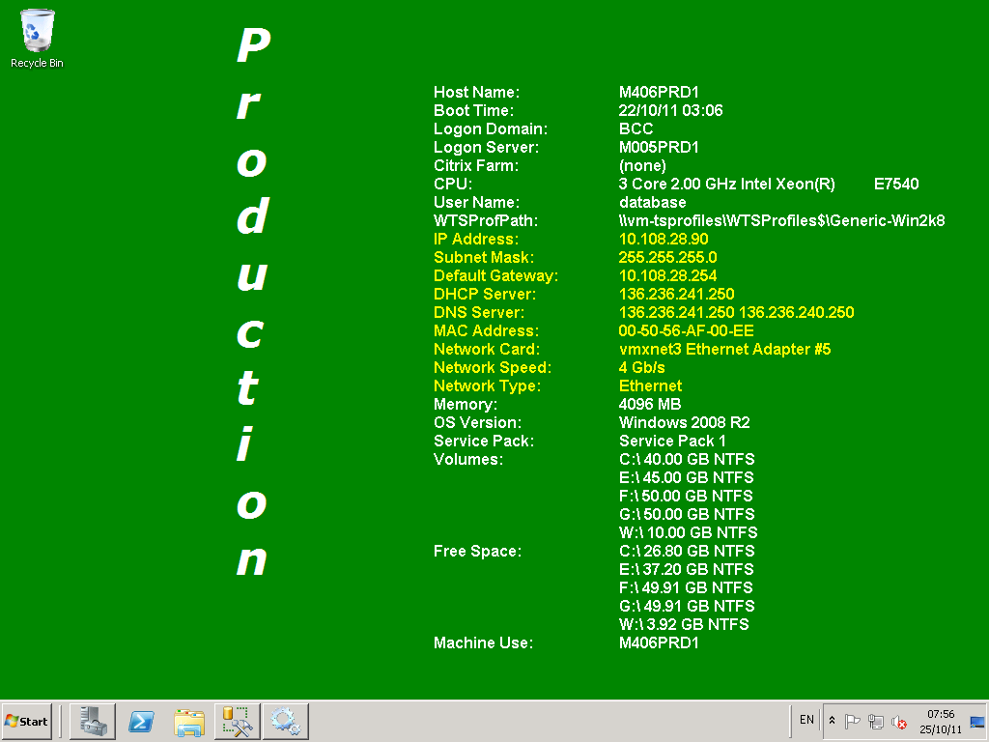

Connect to the target server being built.

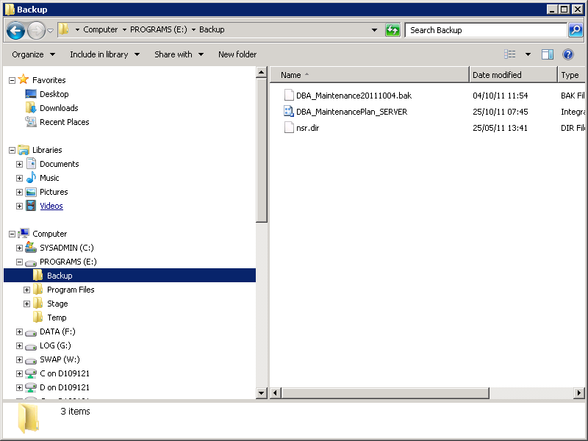
Navigate E:\Backup and locate the File “DBA_MaintenancePlan_SERVER.dtsx”. This is a DBA Maintenance Plan that can be edited to derive a suitable plan for the target database host.

Copy the “DBA_MaintenancePlan_SERVER.dtsx” file as “DBA_MaintenancePlan_SERVER – Copy.dtsx” and then rename the file replacing SERVER with the name of the server. For example for a Non-Cluster Installation this would be something like “DBA_MaintenancePlan_M315DEV1.dtsc”. For a Clustered Installation replace SERVER with the name of the Cluster Resource Group so that the name of the file would be something like “DBA_MaintenancePlan_SEGSDECR04-01.dtsx”. If there are multiple instances then include the instance name in the name of the file.

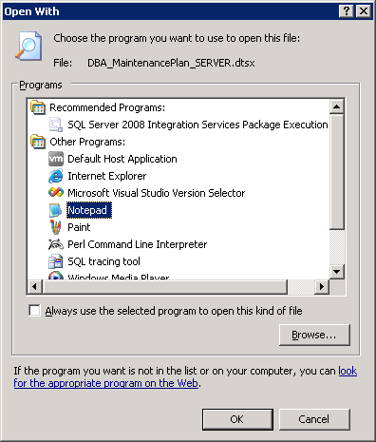
Edit the copied and renamed file with notepad.

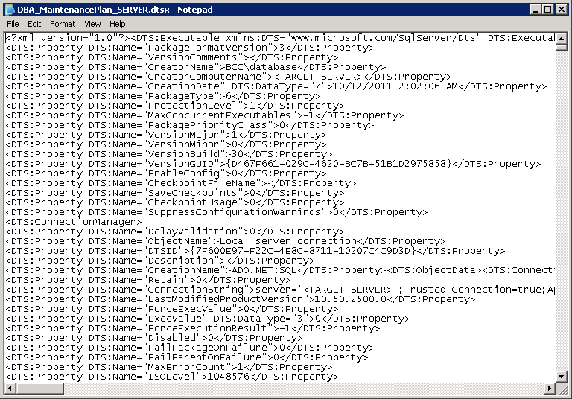

For a Default Instance:
Replace all occurrences of <TARGET_SERVER> with the hostname for the new DB Server.
For example:
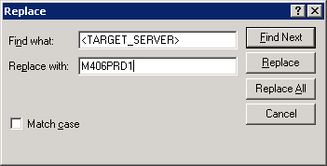

For a Named Instance:
Replace all occurrences of <TARGET_SERVER> with the hostname and instance name for the new DB Server.
For example:
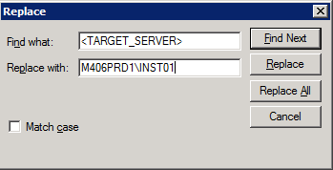

Click Replace All button and then cancel.

If this is for a SQL Server 2012 server the following substitutions will also need to be made:
Replace all occurrences of F:\MSSQL10_50.MSSQLSERVER with F:\MSSQL11.MSSQLSERVER

If this is for a SQL Server 2016 server the following substitutions will also need to be made:
Replace all occurrences of F:\MSSQL10_50.MSSQLSERVER with F:\MSSQL13.MSSQLSERVER

If this is a named instance the following substitutions will also need to be made:
SQL Server 2008:
Replace all occurrences of “F:\MSSQL10_50.MSSQLSERVER\MSSQL” with the path to the SQL Data Root folder. This can be obtained by running the following query and using the value returns in the Data column. Before running the following query replace <INSTANCE_NAME> with the name of the SQL Instnanmce:

EXECUTE master.dbo.xp_regread 'HKEY_LOCAL_MACHINE','SOFTWARE\Microsoft\Microsoft SQL Server\MSSQL10_50.<INSTANCE_NAME>\Setup','SQLDataRoot'
GO

(it is usually something like <DRIVE_LETTER>:\MSSQL10_50.<INSTANCE_NAME>\MSSQL
e.g. I:\MSSQL10_50.SP00\MSSQL)

SQL Server 2012:
Replace all occurrences of “F:\MSSQL11.MSSQLSERVER\MSSQL” with the path to the SQL Data Root folder. This can be obtained by running the following query:

EXECUTE master.dbo.xp_regread 'HKEY_LOCAL_MACHINE','SOFTWARE\Microsoft\Microsoft SQL Server\MSSQL11.<INSTANCE_NAME>\Setup','SQLDataRoot'
GO
(it is usually something like <DRIVE_LETTER>:\MSSQL11.<INSTANCE_NAME>\MSSQL
e.g. I:\MSSQL11.SP00\MSSQL)
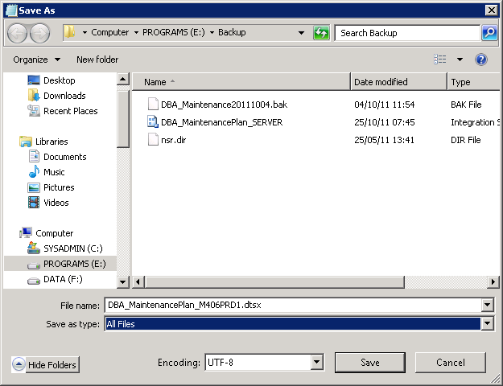

Save the file.

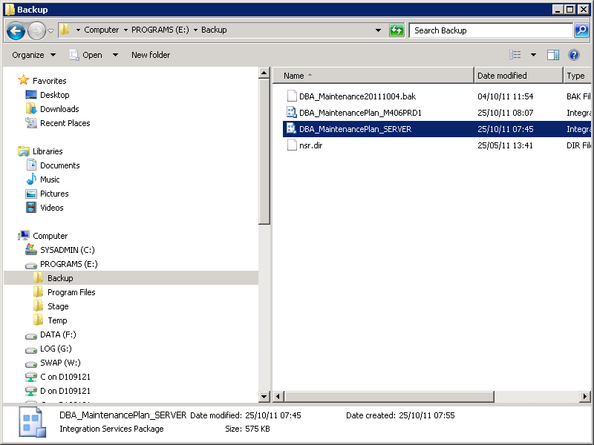
Note you should have at least two dtsx packages now.
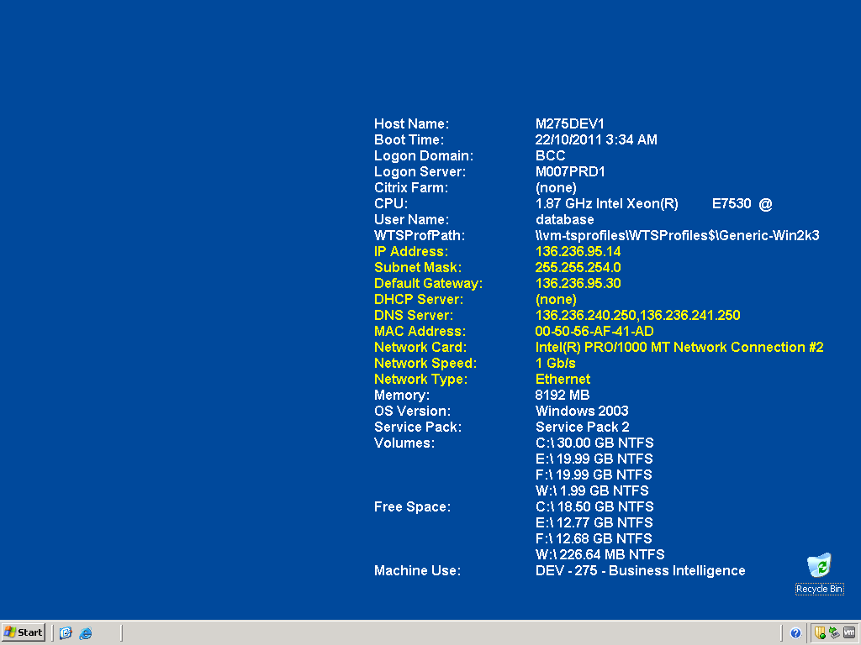
Connect to M903PRD1 through RDP using the bcc\database Login.

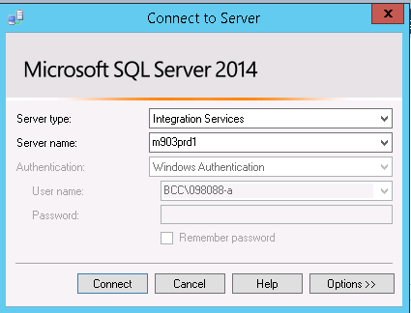
Connect to Integration Services from within SQL Server Management Studio.

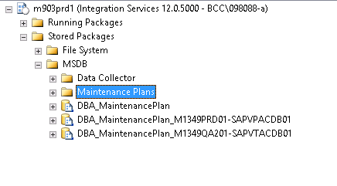

Expand Stored Packages and MSDB then right-click on Maintenance Plans and select Import Package.

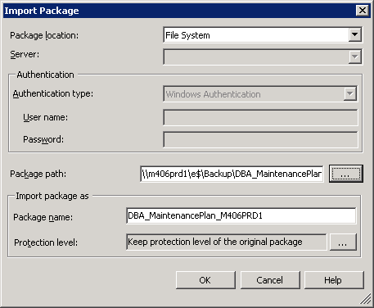

Change Package Location to File System. To determine the Package Path:
- In the Package path field type \\<SERVER_NAME>\e$\Backup\ replacing <SERVER_NAME> with the name of the server
- Click on the ellipsis next to the Package path field
- Highlight the .DTSX file that was edited above and select Open
- Leave the Package name as DBA_MaintenancePlan_<SERVER_NAME> and click OK.

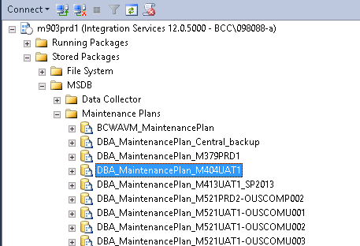

Expand Maintenance Plans. You should see the Maintenance Plan imported into SSIS. Right
Click on the Maintenance Plan just imported and select Export Package.

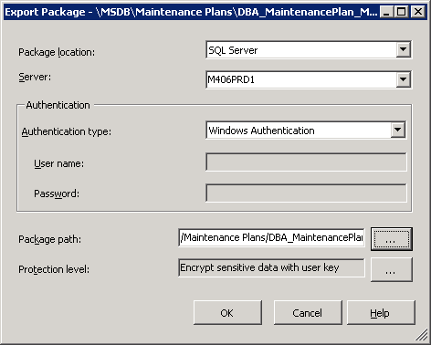

Enter the target server hostname, and the instance name if applicable, into the Server Field.
Click on the ellipsis next to “Package Path”, select “Maintenance Plans” and change the Package Name to just “DBA_MaintenancePlan” and click OK.
Click OK again to export the package.
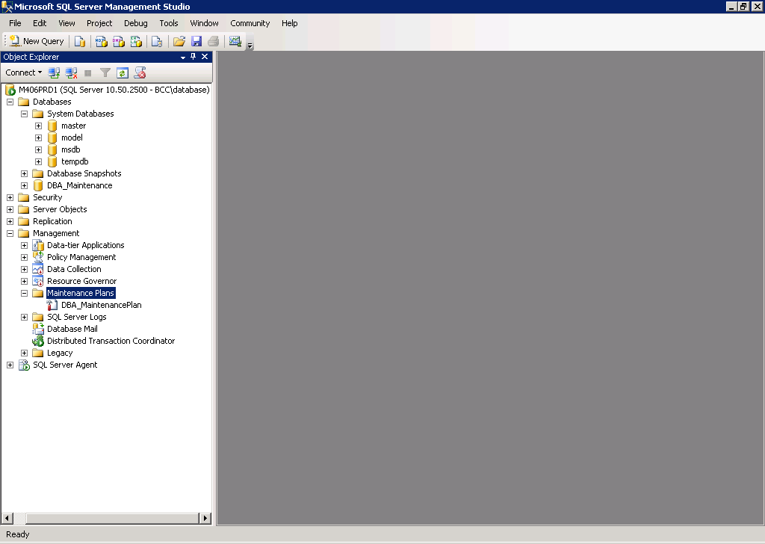
Connect to the Target Database Server to confirm DBA_MaintenancePlan exists on the Target Server.
Navigate to the Maintenance Plans area and ensure the Maintenance Plan DBA_MaintenancePlan exists on the server.

